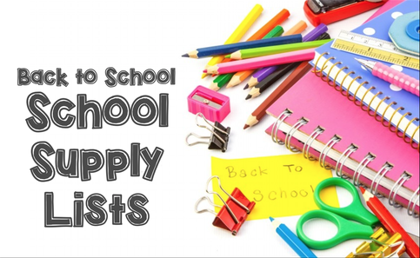

Hello NMS Families!
Just a quick reminder that students are to pay a $50.00 student fee which their school supplies will be purchased from. As well as their student fees, students are asked to bring with them a backpack, a lunch box, a pair of non-marking Velcro sneakers, a water bottle, a box of large Ziplock bags, and a box of small Ziplock bags.

Thanks so much!
NMS Kindergarten Teaching Team

